**Preliminary axisymmetric FEA model of stresses VPZ16LA viewport**

**Introduction**

A finite element model of an VPZ16LA viewport is being created to allow an investigation into the effect of weld ring design on stresses transmitted to the optic. A preliminary 2D mesh has been created to test some of the assumptions and approaches to constructing the model. Once the modelling approach is agreed on, the 2D mesh will be revolved into 3D and bolt holes will be introduced.

The model properties that need to be agreed on include:  
(i) the component shapes and dimensions – unrealistic sharp corners and radii can have a large effect on results.  
(ii) material properties  
(iii) application of constraints and stress

Once we are satisfied that the model is approximating reality, and that we are asking it the right questions to give us the information that we need, we can proceed with the 3D model.

**The mesh**

The optic, weld ring, flange and a braze layer are modelled in cross section (Figure 1). Radii have been incorporated in areas where they may be important, even where not specified on the drawings. The interface between the braze and optic is a crucial part of this model, and the mesh will probably need to be improved so that stress is not unrealistically magnified in this area. For the purposes of comparison of different weld ring designs, the current mesh may prove adequate. The weld region is modelled by simply sharing a few nodes between flange and weld ring. This leaves an unrealistically sharp end to the gap which might magnify stress, but as the region under most scrutiny is likely to be the optic, this is probably acceptable as all it needs to do is transmit forces from the flange to the weld ring. It might be felt that the joined area is not deep enough, or that material should be added to bulk out the weld.

**Material properties**

The material properties used are mostly straight from online databases such as Matweb. These may not be appropriate if the material has been worked or hardened etc. The properties of the braze material are not known and the values used might be described as an informed guess. The material properties chosen are given in Table 1. Young’s modulus is a measure of material stiffness, Poisson’s ratio is a measure of the change in volume of the material on application of stress.

**Table 1:** material properties used in the model

|  |  |  |  |
| --- | --- | --- | --- |
| Component | Material | Young’s modulus / GPa | Poisson’s ratio |
| Flange | 304L | 200 | 0.3 |
| Weld ring | Kovar | 138 | 0.317 |
| Braze | Ag/Sn alloy | 50 | 0.3 |
| Optic | Fused silica | 73.1 | 0.17 |

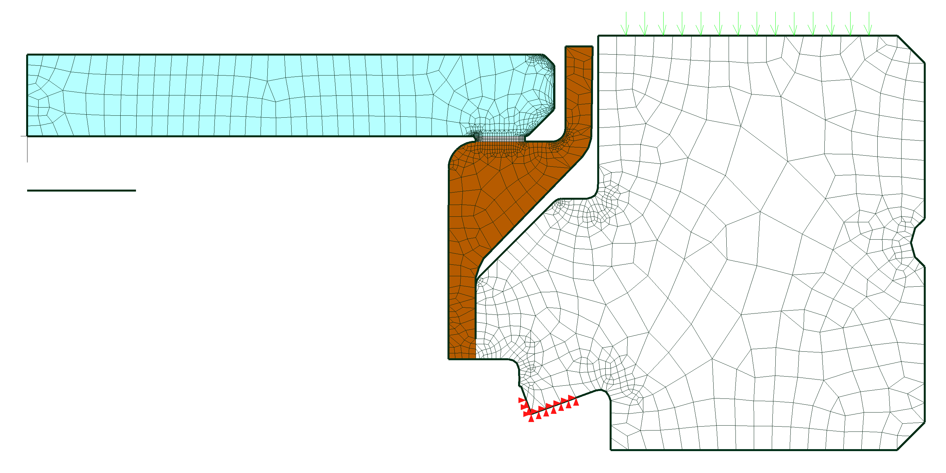  
**Figure 1:** preliminary 2D mesh, with 2 mm scale bar below the optic.

**Experiment**  
To test the mesh, a portion of the knife edge was given fixed supports to mimic a gasket that has compressed and hardened. The knife edge surface with the red markers (Figure 1) is fixed in space and cannot move. To mimic the tightening of bolts, a force was applied across most of the top surface of the flange (green arrows, very faint). A value of 1000 N was chosen. This is unlikely to be realistic, but the actual value is probably not important in terms of demonstrating the distribution of stress in the model.

Although the mesh is 2D, the model type is axisymmetric, which means that the calculation is performed for a uniform 3D circular model having the cross section of the 2D mesh. The points on the centerline are constrained to stay on the centerline, but they are free to move up and down. The force applied and the constraints are distributed around the circular model.

The results of the simulation are given in Figure 2. The deformation is exaggerated by a factor of 1000, and the colour coding is for Von Mises stress, a mathematical combination of the stresses from three dimensions. Most of the stress is concentrated in the flange, especially near the knife edge. The flange has turned about the knife edge fulcrum, moving down at its outer edge by less than 1 µm. The weld joint has flexed and the gap between the weld ring and the flange has opened out. The optic and weld ring have moved up slightly, but they are moving vertically as a unit, and very little of the twisting or bending forces appear to have been transmitted through the weld ring to the optic-braze interface. The rigidity of the constraints applied to the knife edge may have provided some protection to the optic assembly, but the overall turning motion of the flange of the opening out of the gap show that some turning moment (twist) is applied to the weld.

The flexibility of the weld joint and the rigidity of the middle part of the weld ring appear to be the two main mechanisms preventing transmission of the turning moment to the optic, with the lower part of the weld ring absorbing some of the moment.

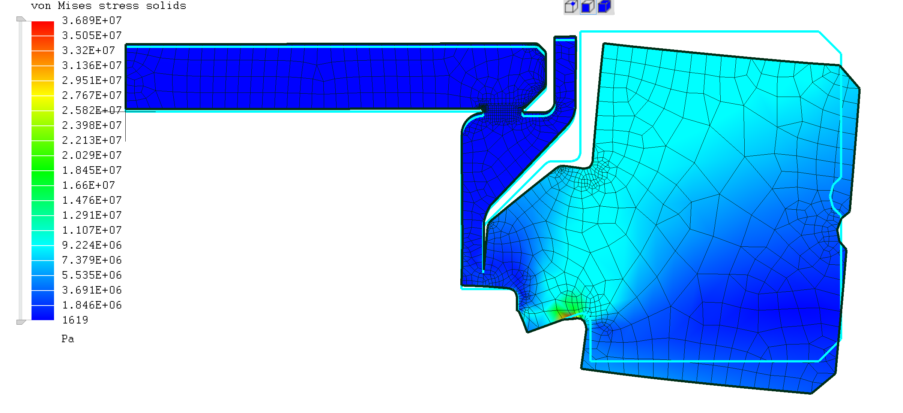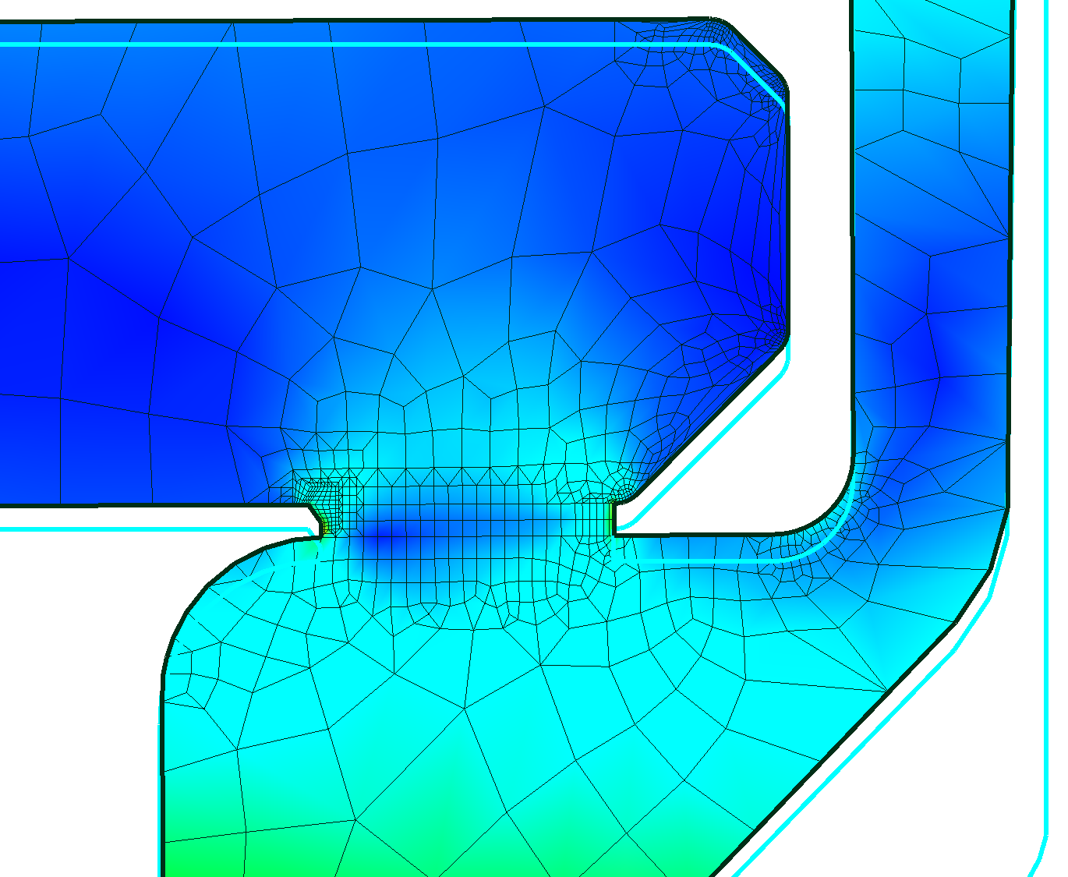

**Figure 2:** the deformation of the model (x1000) under stress, original outline in blue. The colours show von Mises stress (scale on left). The section on the right is a closer view of the optic and weld ring interface, with the colour range reduced to show stress distribution in this region.

**Improvements to the model**

If the results are thought to be unrealistic, then we need to decide what changes need to be made. The material properties are largely not controversial, with the possible exception of the braze. As currently modelled, the braze properties seem unimportant as the stress is not transmitted in any great amount to the interface.

The shape of the weld could be changed so that it is less flexible. The joined interface could be extended (deeper weld), or material could be added beside the knife edge.

It should be possible to constrain the tip of the knife edge from moving down and along, but allow it to rotate in the plane of the page. This might allow more of the twist to be transmitted to the weld joint. It might also be possible to allow the flange to move vertically but limit the twisting, though this is probably less realistic and seems likely to transmit less stress to the weld.

It is a very simple job to change the applied force on the flange.

It is, in principle, possible to include plastic deformation and so the deformation of the flange could be included. The problem is that must be based on data, and we probably don’t have this. If it is felt that thermal stresses and strains from earlier welding or brazing operations is important, these can be modelled and included in subsequent analyses, but this cannot be done with the 2D mesh.

**Conclusions**

As modelled, the flexibility of the weld and the rigidity of the weld ring kept the optic relatively free of stress, possibly aided by the constraints applied to the knife edge. If this does not reflect reality, then we need to consider the material properties and the approach to modelling before moving the model to the 3D stage.